

**The Forest School Ethos**

At Anderton St Joseph’s we grow in love and value a holistic approach to education. The Forest School approach encompasses the physical, emotional, intellectual, spiritual and social aspects to learning and development. Over time children enhance their sense of self, community, belonging and sense of achievement. Forest School takes place in the outdoor environment involving open ended purposeful experiences for all, focussing heavily on the process of learning, encompassing all learning styles. Learners are encouraged and supported to follow their own lines of enquiry, exploring freely in our safe environment whist also having the opportunity to take suitable risks. This type of enquiry-based learning has been proven to develop self- esteem and confidence. This concept originates from the Danish approach to environmental learning and places a huge importance on outdoor learning and the positive impacts this has on a child’s development. St Joseph’s aims to give every child the opportunity to reach their full holistic potential.

**Principles and criteria for good practice The Forest School ethos has 6 principles:**

Principle 1: Forest School is a long-term process of frequent and regular sessions in a woodland or natural environment, rather than a one-off visit. Planning, adaptation, observations and reviewing are integral elements of Forest School.

Principle 2: Forest School takes place in a woodland or natural wooded environment to support the development of a relationship between the learner and the natural world.

Principle 3: Forest School aims to promote the holistic development of all those involved, fostering resilient, confident, independent and creative learners

Principle 4: Forest School offers learners the opportunity to take supported risks appropriate to the environment and to themselves.

Principle 5: Forest School is run by qualified Forest School practitioners who continuously maintain and develop their professional practice.

Principle 6: Forest School uses a range of learner-centred processes to create a community for development and learning

St joseph’s takes the safeguarding of all of its staff and learners seriously and adheres to all relevant legislation with regards to this. This safeguarding policy can be found in the handbook appendices.

**What happens at Forest School**

At St Joseph’s our sessions are designed and led by our Forest School leader. These generally take place on a weekly basis in small or class groups of children. The session last between 1 – 2 hours. The sessions are designed to involve hands on activities and aim to increase learners confidence in their own skills and abilities. Learners are given freedom to explore and engage with the site at their own individual pace. Sessions are child centred and children are encouraged to explore their own interests. Sessions involve the use of natural materials for activities such as:

* Building a range of shelter
* Art and creative activities
* Learning about using knots
* Fire lighting
* Tracking animals
* Bug hunts
* Bird spotting
* Story telling
* Investigating the wildlife and plant life in the area
* Climbing and balancing
* Woodworking to make a range of items
* Creating bug homes and bird feeders and bird boxes
* Collecting, identifying and sorting natural materials such as leaves
* Team

The activities that take place have strong links both to the Early Years Foundation Stage and the national curriculum. Covering areas such as maths and English, art, science, geography and history.

**The benefits of Forest School**

Forest School is open to all ages and abilities and it aspires to develop the learners holistically. It adds value to children’s learning and for those children in particular that may struggle to learn in the classroom environment. Forest School sessions are proven to enhance children’s skills. These skills are then transferred into the classroom environment where learners are found to be more motivated and show high levels of concentration.

• Confidence: children had the freedom, time and space to learn and demonstrate independence

• Social skills: children gained increased awareness of the consequences of their actions on peers through team activities such as sharing tools and participating in play

• Communication: language development was prompted by the children’s sensory experiences

• Motivation: the woodland tended to fascinate the children and they developed a keenness to participate and the ability to concentrate over longer periods of time

• Physical skills: these improvements were characterised by the development of physical stamina and gross and fine motor skills

• Knowledge and understanding: the children developed an interest in the natural surroundings and respect for the environment

Throughout each session, children become involved with the setting and understanding of the Forest school rules to ensure their safety. At the beginning of every session a quick revisiting of the rules is reinforced by the children following our Code of Conduct.



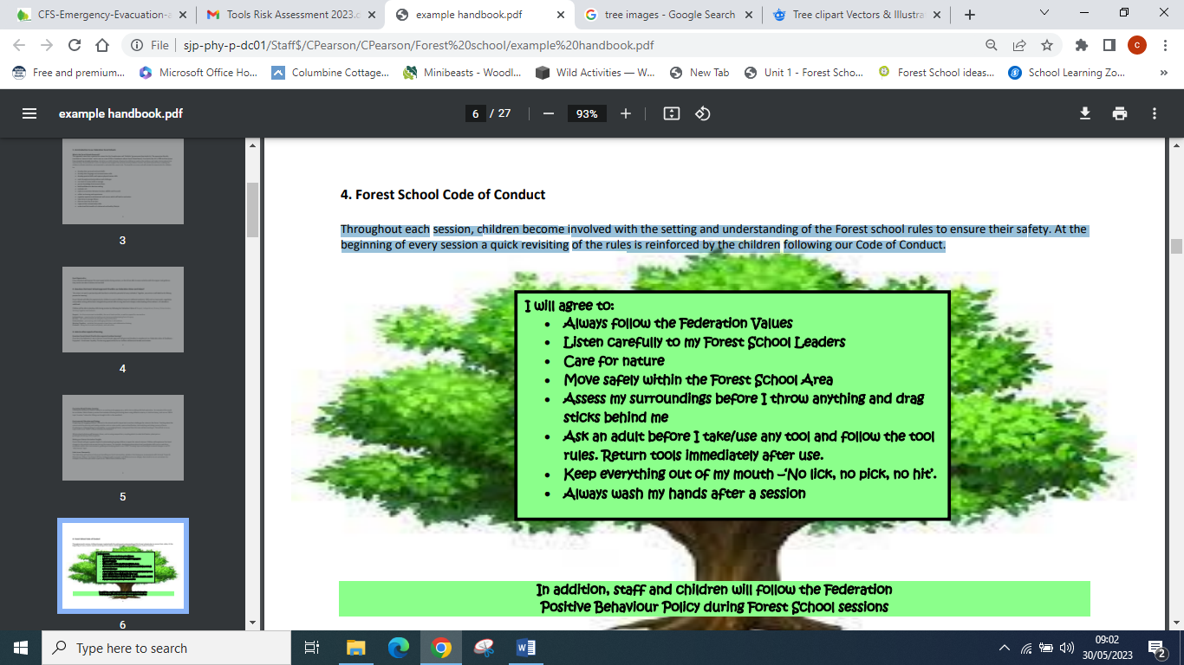

St joseph’s takes behaviour of all it’s learners seriously and Forest school adheres to all relevant behaviour management with regards to this. The full policy can be found in the handbook appendices.

**5. Forest School Staff Our Forest School**

A St Joseph forest school is run by Catherine Pearson who is working towards her Level 3 Award for Forest School Practitioners. She is supported by Damien Dewhurst. All staff and volunteers have undergone an appropriate selection process to assess their skills and suitability for working with children and have been subject to enhanced DBS checks. All sessions are staffed by a qualified first aider and all staff have access to a recommended first aid kit

**The Forest School site**

Our Forest School takes place in a small copse area on our school field. It is made up of mixed deciduous trees, mainly sycamore, field maple, elder, elm, hawthorn and holly. Around the fence area there are a mixture of climbing plants such as ivy. The woodland is will develop over time and we hope to develop a deeper diversity including a new meadow area and newly planted trees and bushes. The site is within school grounds and is not accessible to the public. Children taking part in Forest School will also be encouraged to minimise their impact on the site. This will include:

* Finding out about the different animals and plants that live in and amongst the trees
* Learning to respect animals’ homes
* Careful observation of live animals
* Leaving lying deadwood in place
* Taking all materials and litter with them when they leave
* Ensuring that the site is left like they found it

**Our Forest School Code of Conduct and Procedures**

|  |  |
| --- | --- |
| Entering the Forest School area | Learners will be briefed before entering the area. We show respect for our surroundings and the flora and fauna within. We adhere to the Forest school expectations at all times. |
| Boundaries | We have a set area within the school grounds that is used for our Forest School sessions. At the beginning of our session children will be made aware of the boundaries and area we can learn in. Adults will move around the areas to ensure that they have sight of the children at all times. If you lose sight of a child shout ‘sticky feet?’ The children have been taught to respond by coming into circle, or signal in other ways if non-verbal. This enables the leader to trace children who have strayed. Children who are known to need 1-1 support are given the support needed. |
| Lighting a fire | The Forest School leader will plan and be in control of fire lighting. All adults present at the session will be briefed before the activity begins. All the learners should know who the responsible adult is overseeing the activity . There will be an adult present at all times when the fire is lit. The fire will only be lit when all safety measures are in place. Fires will only be lit in our purpose build area. |
| Fire circle | The open fire will be lit in the centre of the fire circle. The seating for the fire circle is 2metres away from the fire square. All learners must ask for permission to enter the fire circle and receive a response from the leader before they are allowed to enter. Learners are not permitted to run near the fire circle. Only items can be bought into the fire circle by an adult. If the learners are required to leave the fire circle or need to change seating space – they must step out of the fire circle and walk around the outside of the seating. When the area is not in use, we still treat it as if a fire is lit. |
| Use of tools | There is a wide range of tools used at Forest School and require a range of Personal, Protective Equipment and correct use techniques (Please see specific Use of Tools policy for more details) |
| Tree climbing | A risk assessment will be carried out before the learners are allowed to climb. The area will be check for sharp objects and any possible dangers. The tree will also be checked for its suitability. Children are permitted to climb to a maximum of 1.5 metres. A staff member will be present at all times. |
| Carrying and transporting materials | During sessions children can move resources around the site. The learners are taught to move and handle different materials safely. |
| Toileting | We do not have any toileting facilities in the Forest School area. Learners will have the opportunity to use the facilities before we leave the school building. When on site, children can use the facilities in school if needed. The younger children will be escorted by an adult. |
| Leaving the site | We work according to the ethos that the FS site should be ‘left as it was found’. All natural materials harvested and transported will be put back where they were found. Artefacts that are made or found will be photographed and not removed from the FS site. Any equipment used will be taken back and stored at the Setting. All rubbish will be taken back to and disposed of at the Setting. |

**Health and safety**

At St Joseph’s, the Forest School leader undertakes reasonable steps to ensure the health and safety of all participants during ‘activity’ parts of our Forest School sessions as follows:

• Children and staff at Forest School

• Parent helpers and observer visitors Health & Safety Executive (HSE) Play Statement Forest School recognises the value of risk to child development, as outlined by the HSE in (www.hse.gov.uk/entertainment/childs-play-statement.htm) and Scotland’s Play Strategy: “Striking the right balance does mean:

• Weighing up risks and benefits when designing and providing play opportunities and activities

• Focussing on and controlling the most serious risks, and those that are not beneficial to the play activity or foreseeable by the user

• Recognising that the introduction of risk might form part of play opportunities and activity

• Understanding that the purpose of risk control is not the elimination of all risk, and accepting that the possibility of even serious or life-threatening injuries cannot be eliminated, though it should be managed.

• Ensuring that the benefits of play are experienced to the full.

Striking the right balance does not mean:

1. All risks must be eliminated or continually reduced
2. Every aspect of play provision must be set out in copious paperwork as part of a misguided security blanket
3. Detailed assessments aimed at high-risk play activities are used for low-risk activities.
4. Ignoring risks that are not beneficial or integral to the play activity, such as those introduced through poor maintenance of equipment
5. Mistakes and accidents will not happen

**Daily Site Risk Assessment**

A daily site risk assessment (safety sweep) will be carried out before the site is used to ensure that there are no changes to the site which could cause harm. This should be taken with extra caution following high winds and other bad weather. It will be carried out by the Forest School Leader or Deputy and will include anything that is needed to make the site safe (e.g. remove any hazards, mark off any unsafe areas). At the same time will consider specific circumstances which make it appropriate to cancel a Forest School session. Activity risk assessment – When planning activities for Forest Schools, any hazards associated with that activity, that are at risk of causing harm, should be considered. These should be recorded on an activity risk assessment with suitable control measures taken to control and minimise the risk. Due to the nature of Forest Schools the children may come up with a new activity during a session and therefore reasonable steps will be taken to ensure the activity is safe.

St Joseph’s forest school takes the health and safety of all of its staff and learners seriously and adheres to all relevant legislation with regards to this. This Health and Safe policy is an addendum to the settings Health and safety policy. The full policy can be found on the school website.

**Risk Assessment**

In light of the HSE statement above Forest School leaders undertake to ensure that the appropriate circumstances, equipment, knowledge, procedures and training are available to all participants in Forest School. This allows them to ensure the safety of themselves and others during the session. This will be done by Forest School leaders in the following ways:

1. Carrying out risk assessments (RAs)

• generic site and activity Ras

• daily check of site

specific activity procedures (where required)

• dynamic risk assessments of activities that evolve, but are not already covered in a written RA, by making appropriate control actions and sharing these with staff & children (these will be added to a RA after the session)

2. Sharing of risk assessments

• in writing with all staff in advance

• in session plans (where new procedures may be added)

• with whole group at appropriate times during the sessions (including sharing results of daily check)

• during post-session staff review

3.Ensuring effectiveness

• staff will satisfy themselves by that all children and vulnerable adults have the facility to understand relevant health & safety information (additional support will be put in place as necessary

• regular monitoring to ensure that control actions are being deployed

• reassessing, reviewing and changing control actions as necessary. All staff should ensure that they familiarise themselves with the risk assessments and procedures, and implement them. In addition, it is the responsibility of all participating at Forest School to use common sense to keep themselves and others safe.

**Hygiene Outdoors**

Where Forest School leaders are also managing the provision of hygiene and pastoral care, we undertake to provide a safe and healthy working area for all our participants, staff, visitors and children. The following provisions are standard for each session and are listed in the daily plans:

• hand-washing wipes, water and eco-soap are available

• hygienic toileting procedures are in place

• appropriate accident and emergency provision is in place, in terms of equipment, trained personnel and planning

• staffing ratios fall within regional guidelines

• all staff and children have appropriate clothing and footwear for the conditions, and staff use appropriate Personal Protective Equipment for hazardous tasks (i.e. litter picking)

**Child protection policy**

▪ Forest School leaders are DBs checked and are informed in basic child protection strategies and disclosure. Forest School leaders undertake not to be alone out-of-sight with any one child.

▪ All toileting and personal care will be carried out by school staff.

▪ Support staff and volunteers (including parents) engaged by school will be inducted and managed in accordance with school child protection policies by school class teacher.

▪ Any concerns and disclosures will be reported to the class teacher, who will then follow school procedures. ▪ Permission for Forest School leaders to take photographs and use the images in raising awareness of Forest School has been put in place, via an ‘opt-out’ form.

***The full safeguarding policy for St joseph’s can be found in the Handbook appendices.***

**Data protection**

Our Forest school leader undertakes to keep all information relating to this project confidential and to dispose of it in a timely fashion, except where:

• concerns around child protection supersede data protection issues.

***The full data protection policy for St joseph’s can be found in the Handbook appendices.***

**A typical Forest School session**

Before we venture out into our Forest School area, we make sure we are prepared, all learners are dressed appropriately for the weather and that we have the resources that are needed for the session. As a group we will discuss the rules, expectations and routines. We then walk to the Forest school area and gather at the fire area or twigloo. This area is a central meeting place where the group can get together both at the start of the session to discuss activities that may be taking place, talk about what children have enjoyed at the last sessions and what they may be planning to do during the current session. Many of the Forest School activities take place in the vicinity of the fire area. This includes art, games and woodwork. During the session the group will gather back together to have a drink and snack. This can include helping to build and make a fire at the base. When learners are new to the Forest School sessions, time is spent getting to know and explore the surroundings and learning about the basic safety rules that are in place before taking part in more complex tasks and allowing more freedom to explore their own interests. At the end of each sessions, all learners and staff work together to collect and put away all materials and tools that have been used. The natural resources are returned to where they were found.

**Equipment for Forest School**

The Forest School leader will always carry and emergency bag. The contents of this is dependent on elements such as the weather, the type of activities planned and the individual learner needs. This bag contains a range of essential items alongside any tools or equipment used for sessions.

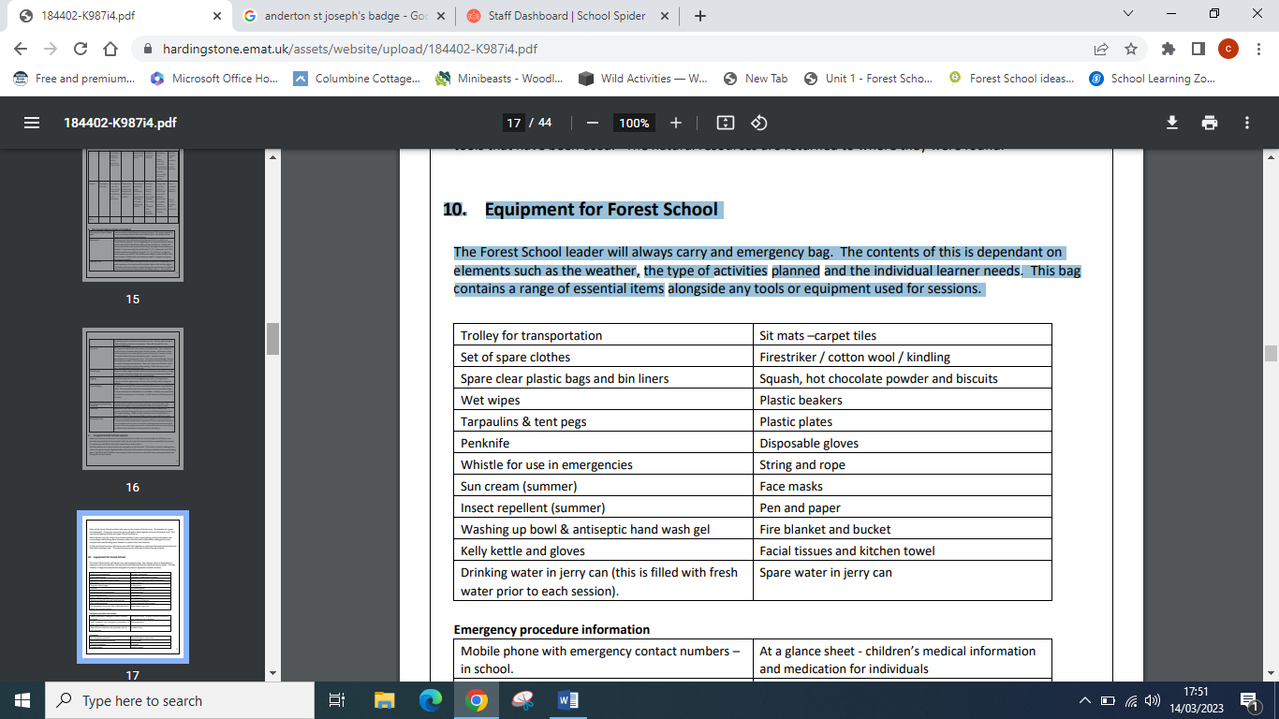

**Emergency procedure information**

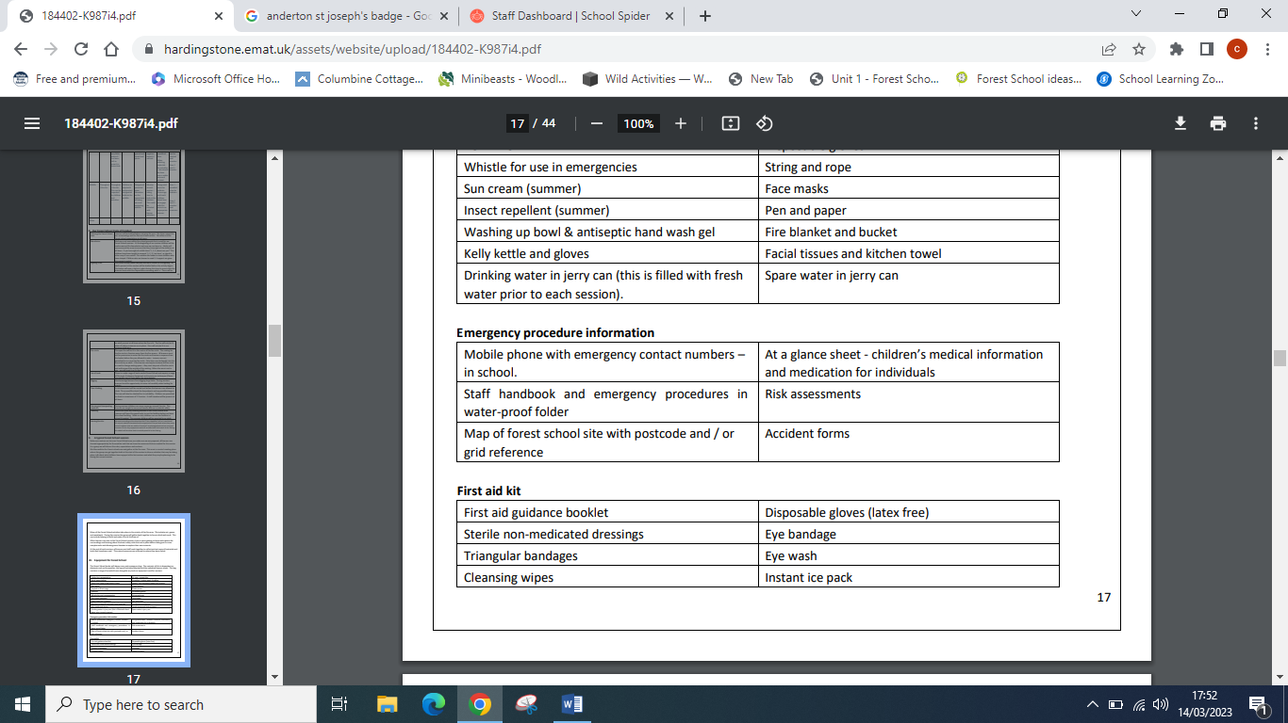

In the event of a minor incident such as a bump or light scratch:

• Class teacher will administer first aid or enable children to self-care while activity session continues as planned. In the event of a more serious incident:

• Forest School leader to administer first aid (whilst ensuring safety of self, group and the casualty)

• Forest School leader will delegate supervision of group to another staff member

• Class teacher will contact school and follow their emergency procedure and reporting procedure. (Teacher to carry school emergency plan and key numbers.)

• Forest School leader will action the emergency procedure (see appendix) Reporting

• Forest School leader will complete incident report form for their insurance purposes • Class teacher will complete school reporting procedures Reviewing

• Class teacher to hold debrief with children

. • Forest School leader to hold debrief with staff.

• All relevant policies and procedures will be reviewed and amended as necessary at that point.

**Essential equipment**

• Forest School to carry group first aid kit and administer first aid in the event of a more serious incident.

• Forest School leader to provide materials for keeping casualty warm.

• Class teacher to carry basic cuts and bumps first aid kit

. • All staff to carry charged mobile phones and ensure they have all relevant numbers. Medical conditions and care plans

• Medical info is stored in school and accessible in event of emergency.

• Class teacher will create a summary of medical and care info, and share with staff on a need to know basis.

• Class teacher will carry all necessary medication and administer any care plans.

**Safety and First Aid**

The Forest School Leader (Catherine Pearson) is a qualified first aider and carries a recommended first aid kit. All activities are risk assessed prior to the session and staff continually monitor the safety of the group. An emergency plan is detailed further in this handbook in the unlikely event of a serious accident. All staff and volunteers have undergone an appropriate selection process to assess their skills and suitability for working with children and have been subject to enhanced DBS.

St Joseph’s takes the health and safety of all of its staff and learners seriously and adheres to all relevant legislation with regards to this. This Health and Safe policy is an addendum to the settings Health and safety policy. The full policy can be found...... weblink etc).

**First aid kit equipment**

* First aid guidance booklet
* Disposable gloves (latex free)
* Sterile non-medicated dressings
* Eye bandage
* Triangular bandages
* Eye wash
* Cleansing wipes
* Instant ice pack

**Tools**

Tool bags and tool box Knives x 5 in lockable box

Bow saw 12” x 3

Loppers

4 Potato peelers x

10 Work gloves - adult’s: 4 & children’s:

10 Tent pegs (blunt ended)

Rope – various sizes inc. poly prop.

1 Billhooks

1 hand drill

**The Forest School Day INFORMATION FOR TEACHERS, STAFF AND VOLUNTEERS Forest** School is a child-centred inspirational learning process, that offers opportunities for holistic growth through regular sessions. It is a long-term program that supports play, exploration and supported risk taking. It develops confidence and self-esteem through learner inspired, hands-on experiences in a natural setting. Responsibilities Clothing It is our responsibility to ensure that children are appropriately dressed for Forest School sessions. Any child not wearing appropriate clothing will not be able to participate. We will provide a shelter from the elements either the wood structure on site or a high shelter made from tarpaulin. It is still important that all learners wear clothes that are warm and that are OK to get wet and muddy. This type of clothing also protects from cuts and scrapes.

Clothing list: -

* warm trousers
* long-sleeved jumper
* fleece or t-shirt
* a vest or t-shirt underneath
* thick socks
* wellington boots
* waterproof coat with hood
* waterproof trousers –(provided by school)
* gloves and woolly hat (cold weather)
* sun hat (warm weather

**Cancellation**

Forest school session take place in most weather conditions. However high winds are extremely dangerous and sessions will not take place if this occurs. Sessions will where possible be moved to another suitable day.

**Use of Tool policy and risk assessments**

Learning to safely use appropriate tools are an important part of a child’s development. They enable a child to fashion instruments for both practical usefulness and pleasure. Tools help children learn how natural materials feel and change and when used safely, help to develop coordination, dexterity and ingenuity. Only Level 3 Qualified Forest School Leaders will train children to use tools and will be responsible for the care and safety of all individuals when using tools, including implementing the safe tool use policy and procedure. All tools have their own clear code of conduct for correct use which will include consideration of specific personal protective equipment, correct use of a specific body posture, and consideration of the appropriate types of activity that each tool may be used for. At St Josephs we will encourage the use of the following tools:

* Hammers
* wooden mallets
* potato peelers
* hand drill
* palm drill
* small hacksaws
* bowsaws
* loppers
* secateurs

**The following guidelines are to be followed when using tools:**

* Hand tools are to be maintained in good order by the Forest School Leader(s) and will be inspected before each session to ensure safety.
* Only tools that are in safe working order will be used.
* Children and adults will be taught how to handle tools properly and to treat them with respect.
* Individual tools will be introduced to children in a structured way, clearly showing how to use each tool safely.
* Whilst using hand tools the staff-to-child ratio is increased to a minimum of 1:2.
* Tools will be kept in a locked Forest School Tool Box and removed only by the Forest School Leader.
* All tools will be counted out at the beginning of the session.
* Tools will not be removed from the designated area. This area will not be included in ‘free flow’. Children will be reminded not to run, walk around with, or point tools at others.
* Children will lose permission to use tools if the guidelines are not followed.
* All tools must be counted back into the tool bag at the end of the session.
* Staff and volunteers must receive training on the use of individual hand tools before being permitted to use them with children.
* Safe working distances will be maintained at all times.
* Initial tool use will be monitored and inform a re-assessment of risk.
* Personal Protective Equipment (PPE): All group members will wear suitable boots/shoes/gloves and outdoor clothing for the activity they take part in.

**Hammers and Mallets**

* 1:3 adult to child ratio when using hammers.
* Items to be hammered should be on the ground or a firm surface, not held in the hands or on the body.
* Nails and stakes will only be dispensed by an adult in small quantities and with careful supervision.
* All nails and stakes will be accounted for and collected back in after use.

**Drills**

* 1:2 adult to child ratio when using drills.
* Items to be drilled should be on the ground or a firm surface, not held in the hands or on the body.

**Peelers**

* 1:2 adult to child ratio when using peelers.
* Peelers will be kept sharp as a blunt peeler is actually more likely to cause an accident.
* When using peelers or knives to whittle, this must be done at the side of and downwards of the body. Children will be carefully instructed on position and technique, and will need to demonstrate they have grasped this before they are given a peeler.
* Children must stay at a safe working distance. This means that they cannot reach or touch another person at full arms’ stretch.

**Saws**

* 1:1 adult to child ratio when using saws, unless two children are using one bowsaw together, in that case 1:2.
* Gloves are to be worn when using any type of saw.
* Saws must have a blade guard in place when not in use.
* Blade guards to be removed and replaced only by the Forest School Leader.
* Wood being sawn must be supported on a saw horse or a natural sawing break – hands must be kept clear of blade.
* Children will be carefully instructed on position and technique, and will need to demonstrate they have grasped this before they are allowed to use a saw.

**Loppers and Secateurs**

* Use of loppers and secateurs must be supervised 1:1.
* Tools must be kept sharp as blunt loppers and secateurs actually pose a greater risk.
* Children must stay in their ‘blood bubble’ for safe working distance. This means that they cannot reach or touch another person at full arms’ stretch.
* Secateurs must have a blade guard in place when not in use.
* Blade guards to be removed and replaced only by the Forest School Leader.
* Only use secateurs with safety catches.

**Tool Storage**

* Tools will be kept in a locked Forest School Tool Box and removed only by the Forest School Leader
* All tools will be counted out at the beginning of the session.
* All tools must be counted back into the tool box at the end of the session.
* Tools will remain in the locked box even when in indoor/outdoor storage.
* The tool box should be waterproof to prevent rusting. Tools should be checked regularly by the Forest School leader and maintained as required e.g. oiling, sharpening and so on. Maintaining tools properly reduces risk.